



|  |
| --- |
| Field Hospital |
| **QUOTATION** |
|  |

**FIELD HOSPITAL QUOTATION**

*Dear Partners,*

*Thank you very much for your interest regarding Field Hospital.*

*We also appreciate your interest in our products and are pleased to submit a detailed quotation. In it you will find all specifications about the equipment .*

*If you should have any further questions please don’t hesitate to contact us . We will be delighted to assist you.*

**MOBILE HEALTHCARE VEHICLES**

At our company, we continue our activities in the sector by designing the vehicles in accordance to international standard for many organizations both at home and abroad.

All services relating our sales before and after, are successfully and reliable performed by us.

We have started our operations in Germany in 1993 and are continuing our 30 years of experience in Turkey and are exporting worldwide.

Our company is working with manufacturers in Turkey which provide the most accurate and superior quality and reliable delivery is part of our success as well as tailor made solutions and we are committed to our customer satisfaction with competitive prices and fast service.

**FIELD HOSPITAL**

MOBILE FIELD HOSPITAL Container

The Field Hospital is an innovative medical facility that offers detailed medical care, similar to a traditional hospital but with added units. It is designed to provide quick and effective solutions in the face of extraordinary situations. The hospital can be customized to meet the specific needs of its customers, in addition to its standard configuration. The main structure of the hospital is made up of a variety of ISO containers, which provide a flexible and adaptable space for medical treatment. This unique approach ensures that patients receive the best possible care, no matter where they are located.

Field Hospital can consist of these parts , Emergency Laboratory Unıit

Pharmacy Unit X-ray Unit Laundry Unit Sterilization Unit Intensive Care Unit x2 Operating Theatrex2

Blood Collection Unit Power&Water Network Toilets

* Area Dimensions : 28.5 m x 17 m
* 7 x Container ISO 20 ft IC-4010
* 5 x Container Expandable

The Area for Field Hosptal is **approximately 700 m²**

**PROJECT PLAN**

|  |
| --- |
|  |
|  |

**PROJECT INTERIOR DESIGN**

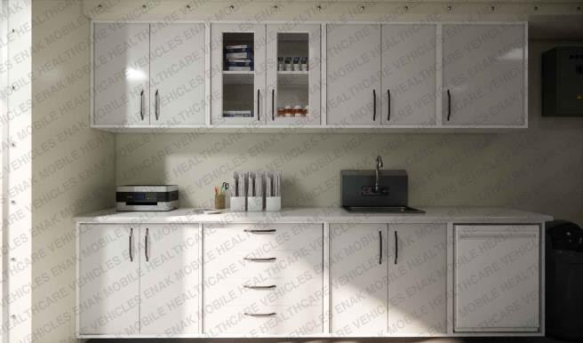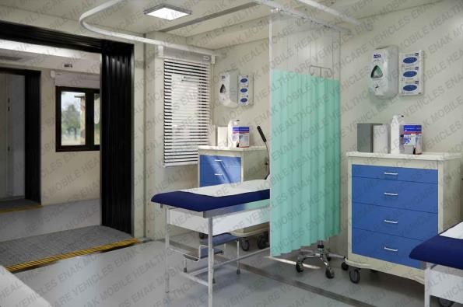

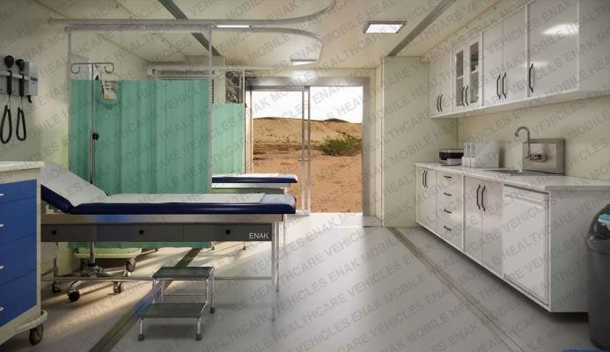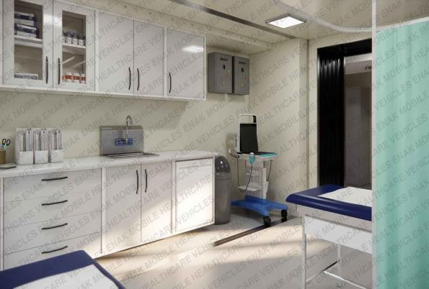

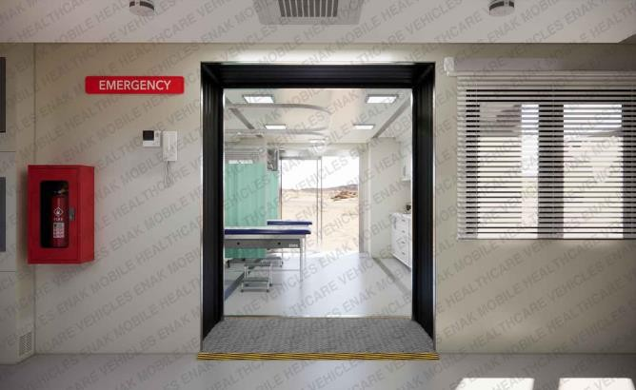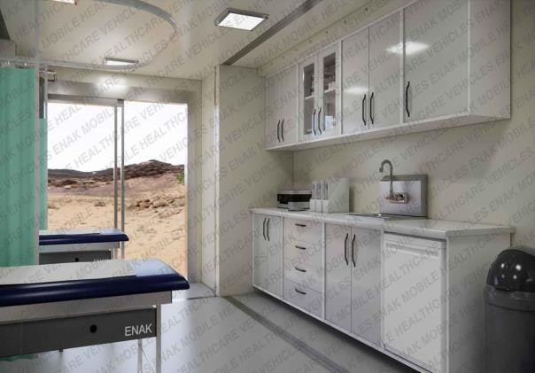

**OTHER MATERIALS**

**VEHICLE SPECIFICATIONS**

**SOME OF CONTAINERS TECHNICAL DESIGN**

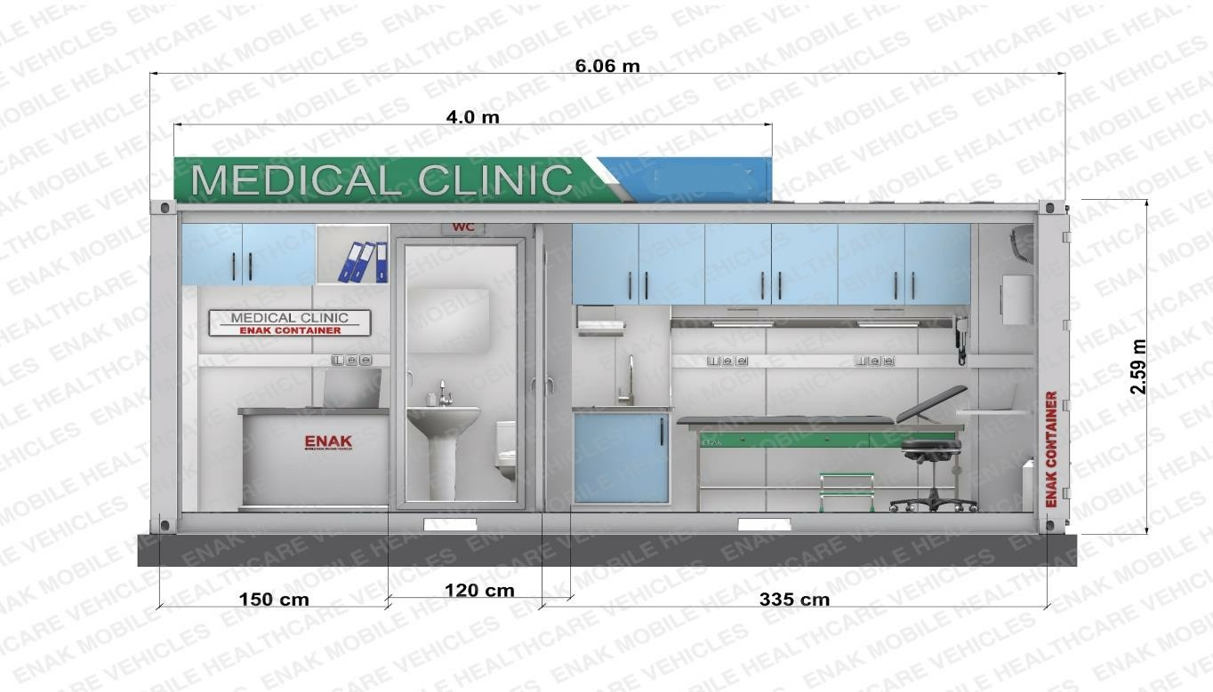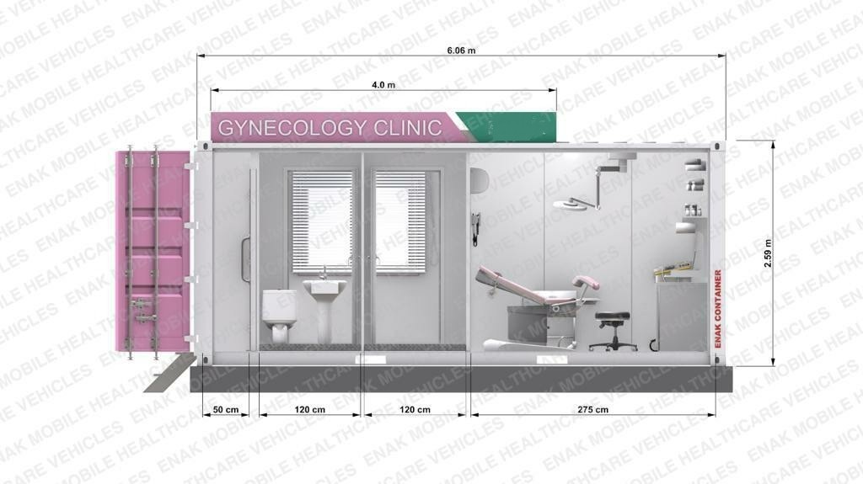

**SOME OF CONTAINERS TECHNICAL DESIGN**

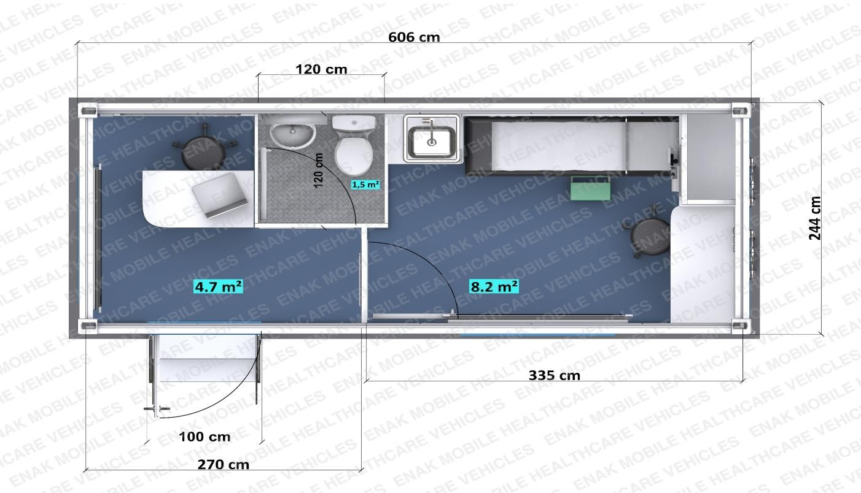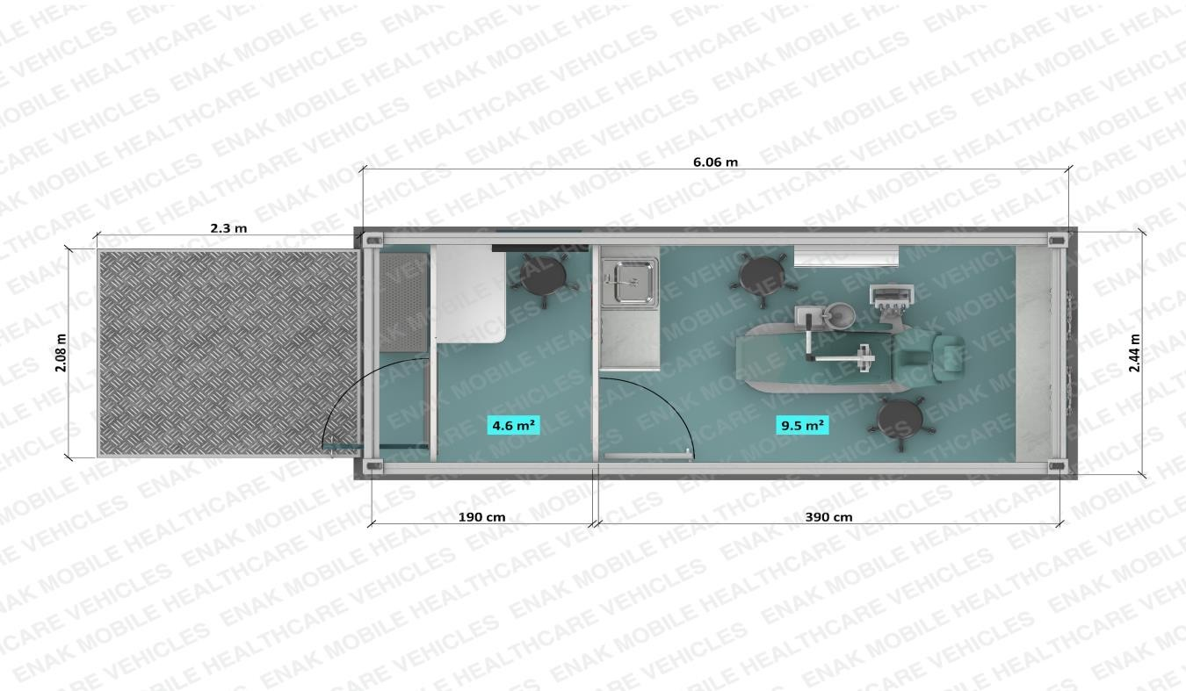

**PRICING**

**TOTAL**=690.000 EUR

|  |  |  |
| --- | --- | --- |
| **ENAK FIELD HOSPITAL** | **UNIT PRICE** | **TOTAL** |
| ENAK FIELD HOSPITAL |  | 900.900 Euro |

**NOTES**

* Our prices do not include any taxes or custom charges or transportation charges.
* All prices are factory gate prices /EX Work
* Delivery time:120 days after confirmation of the order.
* Payment terms:80% on definite order/contract signing date,
* %20 on dispatch
* The prices above are not valid for the Turkish market.
* The equipments inside the containers are with **CE Certification** and under warrant for 2 years
* The Transportation cost **change day by day**.So we can’t give the real cost. We must ask to transportation company